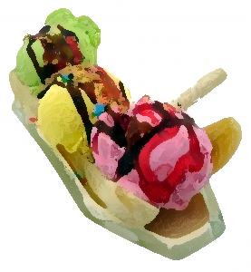
Ice Cream Shop

Our Mission Statement
The Ice Cream Shop’s mission is to be one of the finest producers of unique quality ice cream in the industry while modeling excellence in how to treat employees and consumers. Our motto is “We will create any flavor ice cream the customer requests!”
“We love the unique creative flavors available from the Ice Cream Shop. It makes birthday parties and special events so much more fun!” ~ The Party People, Salt Lake City

Make You Own Flavors
Have you ever wanted an ice cream flavor no one makes? Like Jalapeno flavor. Or Rhubarb? How about a simple combination of popular flavors that are difficult to find, such as peanut butter and pecans?
The Ice Cream Shop specializes in creating unique flavors. We also combine popular flavors in ways you can’t possibly imagine!

Our Most Popular Flavors!
We have a plethora of ready-made flavors. Here are some of our most popular for the past year.
Flavor | Flavor of the Month Awards
Chocolate Heaven Splurge | February, March
Fruit Heaven Splurge | April, May
Jawbreaker Mint | August, September, October
Pecan and Peanut Truffle | January, June, July
Whole Vanilla Bean Chunk | November, December

Customize in Almost No Time
Need a special flavor for a special party next week? We can do it! Most of our flavors can be created and available for pickup in just 72 hours. Rush orders are also possible and can be picked up in only 24 hours for an additional fee. Give us a try. We promise you won’t be disappointed. Our company is family owned and has been producing ice cream for three generations. We know our business and we love our customers. And we especially love ice cream!

Focus on What You Do Best
Our customers range from consumers to resellers. Our consumers buy ready-made flavors from our retail store. Our resellers place custom orders which they then provide to their customers. We do it all! Let us worry about making the right flavor ice cream so you can focus on what you do best.

Key Clients
Our ice cream is so good, our customers come back over and over again. Below is a list of our biggest clients.
- The Party People
- Birthdays R Us
- Did You Say Party?
- I Scream, U Scream

Contact Us
Company Name
Street Address
City, ST ZIP Code
(801) 123-4578

